Homework Week #2

(20 points total)

Using what you’ve learned so far in the course, specifically during week 2, answer the following questions.

Question 1. (3 points)

Type the three following commands, hitting enter after each entry. Now recall and change those commands as described. Submit your updated command and results to parts a, b, and c.

$cat /etc/group

$ls $HOME

$date

1. Using command-line recall (up and down keyboard arrows), recall cat and change /etc/group to /etc/passwd.

**Input:**



**Output:**

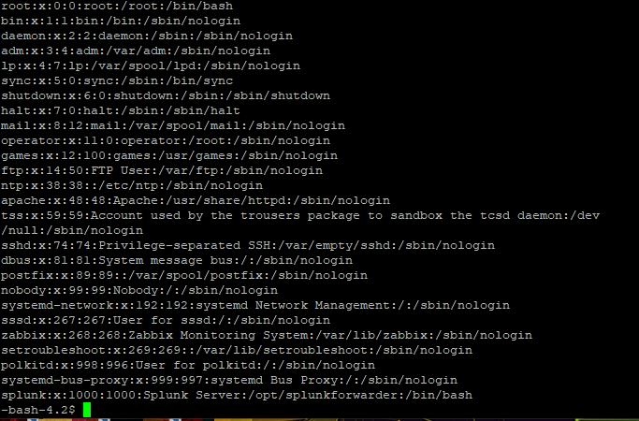

b Recall the ls command, determine how to list files by time.

**Input:**



**Output:**



c. Add format indicators to the date command to display the time only. Exit

ls

**Input:**



**Output:**



Question 2. (1 point)

In a long listing of a file, what indicates that the file is a regular file?

1. The word “file” displayed at the end of the file’s long listing.
2. The character “d” displayed at the beginning of the file’s long listing.
3. The character “f” displayed at the end of the file’s long listing.
4. **The hyphen (-) displayed at the beginning of the file’s long listing.**
5. The hyphen (-) displayed at the end of the file’s long listing.

Question 3. (1 point)

Assuming all the following files are present in the current working directory, the command **ls**  **e\*** would find which files (Choose all that apply.):

1. botnet
2. **emacs**
3. ENIAC
4. cat
5. Botnet

Question 4. (3 points)

Perform the following actions and show the results of each step. From your home directory, using an absolute file path switch to the ‘etc’ directory. Using a relative file path, move to the “/etc/skel” directory. Provide a long list of the contents of this directory.

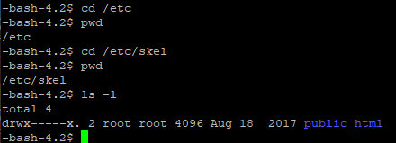

Question 5. (3 points)

Answer which of the following either an absolute pathname, a relative pathname, or a simple filename? a. **myfiles_co** (simple filename)

1. **business/myfiles** (relative pathname)
2. **/home/josh** (absolute pathname)
3. **/home/josh/classes/cs2080** (absolute pathname)
4. **..** (relative pathname)
5. **letters.123** (simple filename)

Question 6. (5 points)

Assume the working directory is **/home/josh** with a subdirectory named **classes**, give three sets of commands you can use to create a subdirectory named **cs2080** under **classes**. Now provide two sets of commands you can use to remove the **cs2080** directory and its contents.

**Create:**

mkdir classes/cs2080 or mkdir /home/josh/classes/cs2080 or mkdir ./classes/cs2080

rm -r /home/josh/classes/cs2080 or rm -r /classes/cs2080

Question 7. (2 points)

When manipulating running processes within Linux via the command line, knowing the process ID is essential. Can you list two ways to identify the PID number of the shell?

ps u or top

Question 8. (2 points)

Create a directory hierarchy, so that your user home folder contains at least two sub-directories, and each contains at least one inode. What single command allows you to display your user home hierarchy? (Show your results)

